Price Reporting in C2
PITS 60237 & SEDL 9536
Test Plan

Rajesh Deshmukh, Ext. 7607

Table of Contents

Problem Description – SEDL 9304 3
Resolution 3
Test Case 1 – Spread – Spread should not trade through resting AON Order 3
Test Case 2 – Spread – Spread Trade without AON 4

Problem Description – SEDL 9536
We are unable to to issue a price report (via. Enter Manual Price function on Trade GUI) on C2. This includes deleting or adding a price report.

Resolution
Changed the Market Data Service XML to change the session names, due the different session name, manual price reports were rejected by the system. After changing the session name in Market Data Service XML Manual price reports are accepted by the system.

Test Case 1 – Enter manual price report

Test Procedure:
Session, Class & Product: C2_MAIN, simple Option & any valid Series
Set below using SA GUI:
- Open the simple option product
- Create Reporting user and assign him reporting role.

Enter Quotes 100 @ 1.00 and 100 @ 1.20 on option product,
Enter Order Sell 100 @ 1.00
Second Order should trade at 1.00 for 100 quantity.

Login trader user as a reporting user, Who can enter manual report prices.
Please do the following steps to enter manual price.
- open Market Display on the trader GUI
- add class AAPL to the market display window
- right click on manual report price entry.
- Enter 100 Quantity and 1.00 Price
- Broker is XXH and Contra Broker should be ABC
- Don’t select the PREFIX and submit the request.
- Request should get accepted and you should see below accepted message on the screen.
- In market History window you should see entry for the manual price report entry

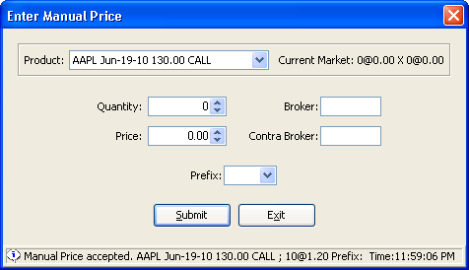

Test Case 2 – Cancel Manual Price Report

Test Procedure:
Session, Class & Product: C2_MAIN, simple Option & any valid Series
Set below using SA GUI:
- Open the simple option product
- Create Reporting user and assign him reporting role.

Enter Quotes 100 @ 1.00 and 100 @ 1.20 on option product,
Enter Order Sell 100 @ 1.00
Second Order should trade at 1.00 for 100 quantities.

Login trader user as a reporting user, Who can enter manual report prices.
Please do the following steps to enter manual price.
- open Market Display on the trader GUI
- add class AAPL to the market display window
- right click on manual report price entry.
- Enter 100 Quantity and 1.00 Price
- Broker is XXH and Contra Broker should be ABC
- select the PREFIX as CNCL and submit the request.
- Request should get accepted and you should see below accepted message on the screen.
- In market History window you should see entry for the manual price cancel report entry

